Trevor Lee How Does a Bike-Share Navigate Speedy Success? 12/16/2021

Subscription bike services and usage are becoming more prevalent in recent years. Cyclistic wants to ensure that it can not only meet the demand for a healthier lifestyle, but also provide a membership to the riders who are interested and invested for the long-term. This analysis identifies the casual riders whose ride patterns are similar to those of the annual riders that would be most interested in an annual membership.

The casual riders who would be most interested in an annual membership are those that ride less than 120 minutes per ride 1) have a median and mean ride length similar to the annual rides (which is lower than the median and mean ride length of casual rides), 2) are riding the classic and /or electric bike and 3) have similar engagement during the weekdays and weekend. There are some caveats that will be discussed when making conclusions based on the data and analysis.

Identifying Casual Riders to Convert

Casual and annual riders are different as casual riders, surprisingly, have greater engagement per ride (median ride length of 18 minutes vs 10.45 minutes for annual riders).

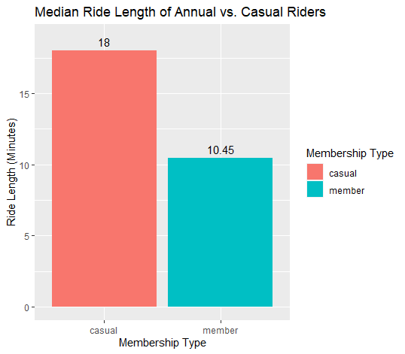

The goal is the find which casual riders or behavior patterns exhibited by casual riders most resemble those of the annual riders, so that Cyclistic has a better idea of which riders to market to. It would be best to have all casual riders converting to the annual membership, but that is not realistic, so it would be wise to focus Cyclistic’s resources on the 97% (a large percentage of riders to help) of casual riders who are more similar to annual riders in terms of engagement

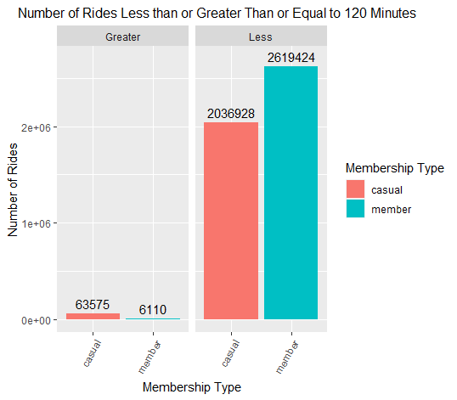

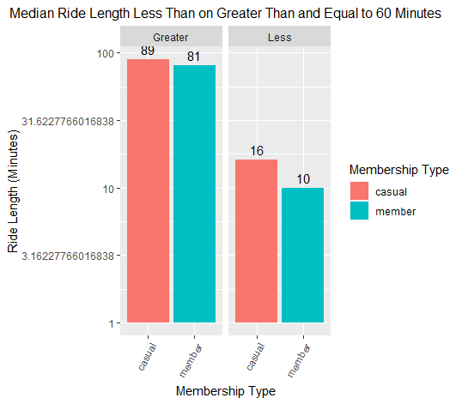

Finding the Median Ride Length Sweet Spot for Conversion

Although casual rides have greater engagement across all combinations of various variables (month, day of week, ride type, and season), Cyclistic can focus on the casual riders whose ride length engagement is similar to those of the annual riders, accounting and accepting for a small deviation.

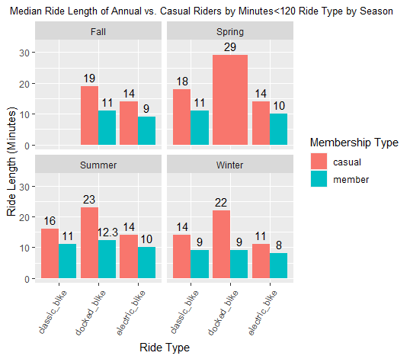

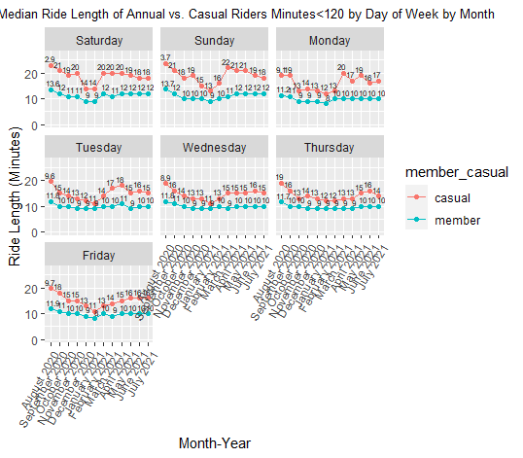

Casual median ride length is higher across the board after controlling for all variables at every data point. This means the riders to convert to annual members must have a similar ride engagement to annual members from the casual member group, controlling for the various variables.

Converting Via Bike Type

Cyclistic should focus on converting casual riders that ride only or mostly the classic and electric bike. Since February 2021, there are no rides on the docked bikes by annual members. Although it has the highest engagement for casual rides, the resources for conversion should not go towards riders that ride only or mostly the docked bikes. This is not to say that docked bikes should be discontinued, as it is the most popular ride type at all months for casual rides, and therefore a good revenue generating opportunity (it seems even with churn).

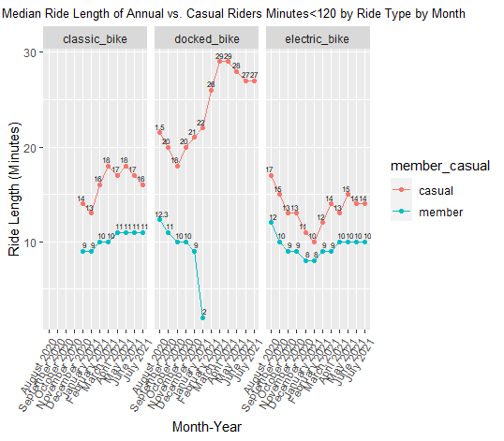

Day of Week Pattern Among Annual Members

Cyclistic should convert casual riders who ride (taking into account the above factors) consistently (in terms of ride length) across all days of the week. The drop-off in ride length across weekend to weekday is not as much for annual members as it is for casual rides. One caveat is that we do not know if annual riders are riding the same ride time every or most days or if different riders are riding the same ride time at different days. If annual riders ride the bike most days, they are riding consistently across multiple days, and possibly a consistent length, making Cyclistic a lifestyle or habit.

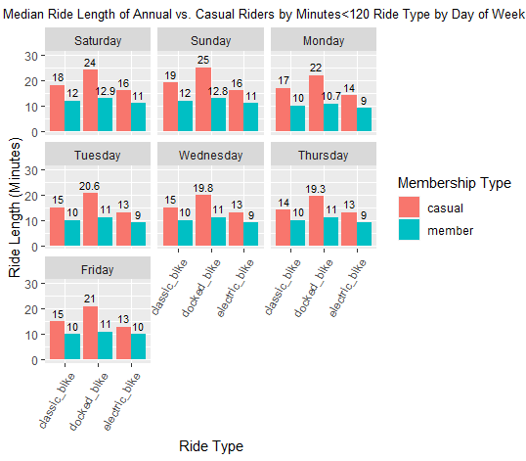

Caveats

There are a few ideas that need to be clarified in regards to the data, conclusion, and its context. First, the data is based on each unique ride, and not each individual rider, which there is no data for, and would be helpful to illuminate patterns of individuals in each membership type.

The current analysis provides recommendations based on the behaviors of casual vs. annual members as a whole. With data from each individual rider, one can create a social graph, and better understand churn rate, demographics, and any other patterns. Without individual data, one can only guess if the annual riders consist of only a handful of annual members that ride all the time or lots of annual riders that ride in disparate days, or months, or somewhere in between. How many customers churn, and then sign-up again, can not be answered without more customer specific data.

Analysis from this report uses data from August 2020 to July 2021, which is limited at best. It is best to look at the data from a larger scale and time period, as more trends can be seen. The number of riders/rides may increase year over year, and that may a companywide increase or possibly just an industry increase – proving the need for market data as well. Is Cyclistic doing something right or is an upward trend indicative of rising tides across the board.

Qualitative data would also provide better context and information for understanding conversion of casual riders to annual members. For example, biking can be a very social activity, whether it is between family, friends, or a group/club. It would helpful to understand if more people become members if they are riding in groups or due to the social nature of the activity. Qualitative data that can be collected can range from photos, videos, time and date of de/activating the bike, surveys, etc.

Casual riders have a higher mean and median ride length and a few reasons are possible. The first could be that a lot of casual riders may not know the proper operating procedure to how to sign off their ride. This seems to be at least partially true if one looks at the end time and date for a lot of the rides, well over 2 hours. Even for the under 2 hours casual rides, there may be some of them that were not signed out properly. At the end of the day this is still revenue for Cyclistic if they charge per minute, but would possibly turn off conversions.

A second reason that casual rides are generally longer that annual rides are that a lot of the rides may have been ridden by tourist, therefore they want to spend more time on the bike traversing the locale. A third reason is that casual riders may use the bike as a one time event so want to spend a lot of time with it. The annual riders may use it to get to work, which may be quick and consistent, or have a set routine. So this would be a difference in lifestyle.

Future Ideas

Building on the previous point, Cyclistic should explore an annual membership discount for pairs/groups. Marketing and introducing cycling through Cyclistic as a social activity scales the number of riders using Cyclistic. Once Cyclistic converts riders, it needs to follow (with individual data) if and when these customers churn, and if they re-up, and why. Furthermore, Cyclistic can hold bike riding events and classes to introduce customers to Cyclistic and increase conversion and stickiness.

If Cyclistic markets their annual membership (and it seems this way from the analysis for annual rides) as a lifestyle choice, then the conversion may not be high. But if Cyclistic holds events to build up biking as a healthy choice, and partners with non-profits, the government to improve the lives of its citizens, decrease traffic congestion, and decrease carbon dioxide pollution, it has a better chance of converting casual rides and new members to the annual membership.

Methodology

All analysis was done in R, and some data preparation was done in Excel. The started_at, ended_at, start_station and end_station id and name, start and end longitude and latitude were excluded as there was a lot of missing data, therefore hard to compare apples to apples. Also some of the columns were not necessary for the analysis. A Seasons, ride length in minutes, day of week, and month column, was added.

Conclusion

Based on the analysis, Cyclistic should focus on casual rides that are most similar to annual rides. The annual rides’ behavior are less than 2 hours with a median ride length of 9-12 minutes, riding the classic and /or electric bike, and have similar engagement during the weekdays as the weekend.

Social riding, riding as a lifestyle, riding classes/events, and partnering with non-profits and the government to promote the benefits of riding with Cyclistic are other opportunities to be explored further.